* **Explore Anaconda’s official website for tools, resources, and updates.**

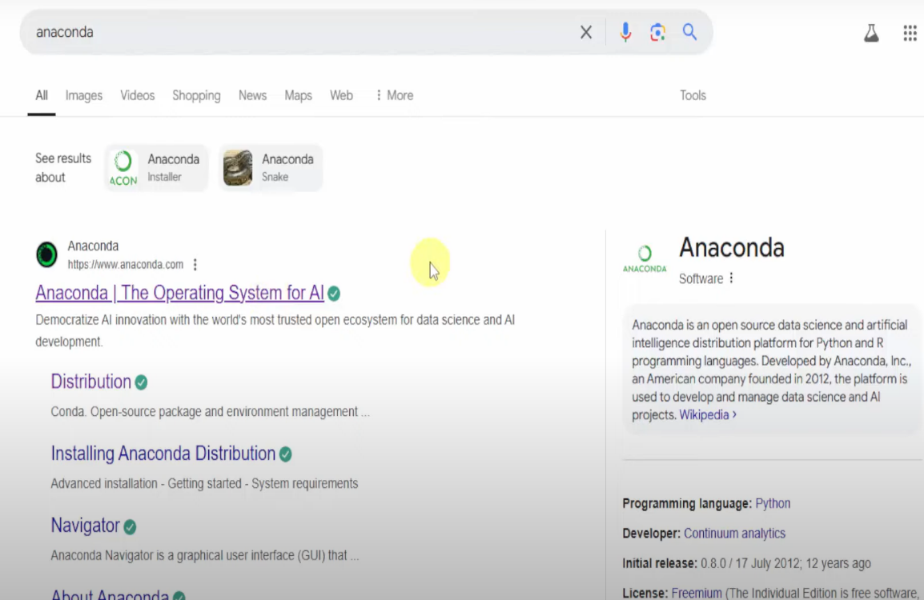

* **Go to the Download section to access the latest software.**

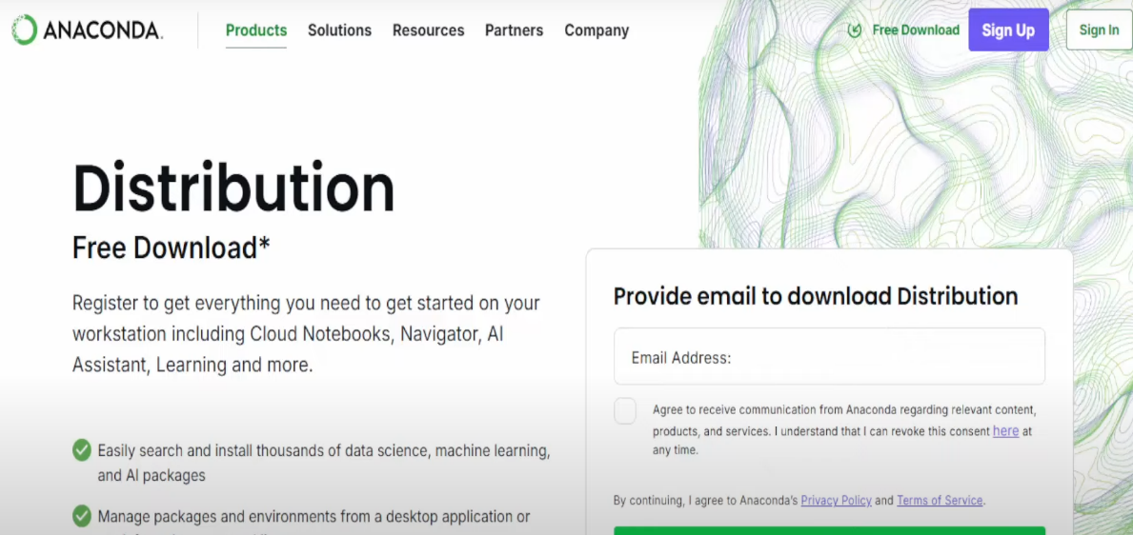

* **Select the right installer for your system setup.**

* **Click to start your download.**

* **Launch the setup to begin installation.**

* **Review and accept the license agreement to proceed.**

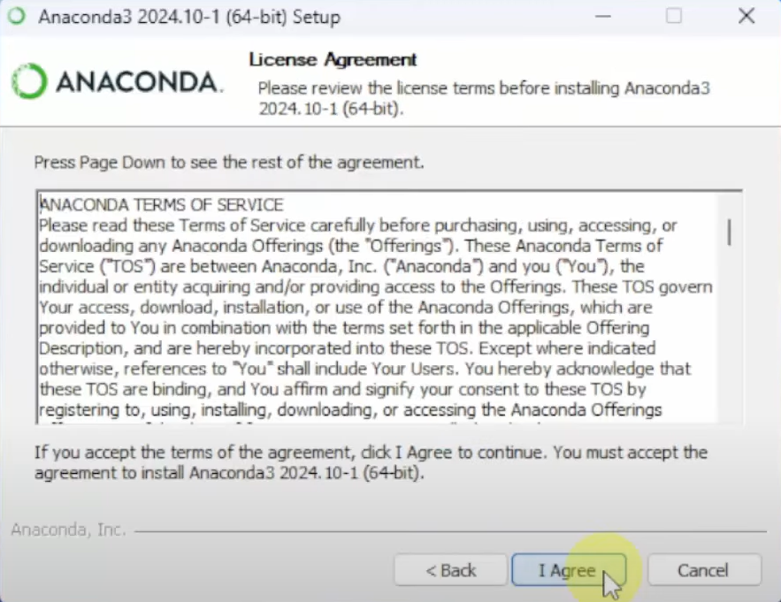

* **Select your preferred installation type to continue.**

* **Review and confirm your selection to proceed.**

* **Choose the folder where you want the software installed.**

* **Adjust installation settings to fit your preferences.**

* **Installation is starting. Please wait.**

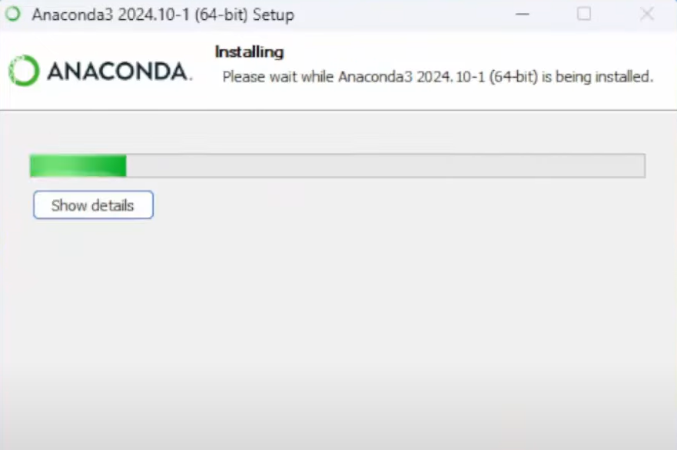

* **Your installation is underway. Please be patient.**

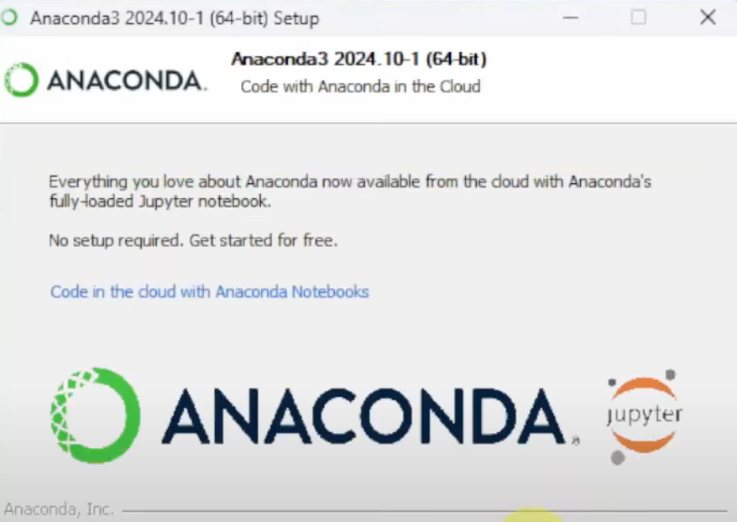

* **Installation is complete. You’re ready to get started!**

* **Choose to install VS Code for enhanced development features.**

* **Complete your setup and start using the application.**

